Swapping Charging Station report by
Electronics Team

- Revision Number:
Rev. 2.0
- Date of Creation or Update:
3/2/2025
- Prepared By:
Muhammad Sabahat Akhter
Muhammad Suleman

Reviewed By:

1.Purpose
The testing of the Swappable Charging Station was conducted to analyze the functionality of all 12 slots while batteries were being plugged inside each cabinets. The objective was to evaluate the system's performance under partial and full-load conditions. A fatigue test was conducted on February 3, 2025, to assess long-term performance and durability. During this test, all 12 slots were functional and charging properly, confirming the stability of the charging system under extended operation.

2. Load Testing Observations
During testing, the following AC current measurements were recorded as batteries were sequentially plugged in:
Number of Batteries Plugged In | Observed AC Current (A) | Calculated Power Consumption (W) at 220V AC
1 Battery | 7.8A | 1,716W (7.8A × 220V)
2 Batteries | 14.1A | 3,102W (14.1A × 220V)
3 Batteries | 17.8A | 3,916W (17.8A × 220V)
4 Batteries | 23.4A | 5,148W (23.4A × 220V)

Since only 4 batteries were available during testing, full-load conditions could not be assessed. However, the power consumption trend suggests that when all 12 slots are utilized, the total power consumption can be estimated.

3. Estimated Power Consumption for 12 Slots
Assuming a linear increase in power consumption, the estimated AC current and power consumption for all 12 slots in operation can be calculated:
- Average AC current per slot:
  - 23.4A ÷ 4 = 5.85A per slot
- Estimated AC current for 12 slots:
  - 5.85A × 12 = 70.2A
- Estimated power consumption for 12 slots:
  - 70.2A × 220V = 15,444W (15.4kW)
Thus, the charging station is expected to consume approximately 15.4kW when all 12 slots are simultaneously in operation.

4. Fatigue Testing Results (February 3, 2025)
To evaluate long-term operational stability, a fatigue test was conducted on February 3, 2025. The key findings are:
✔ All 12 slots were functional and charging properly throughout the testing period.
✔ No overheating, voltage fluctuations, or system malfunctions were observed.
✔ The charging station maintained consistent performance without disruptions.
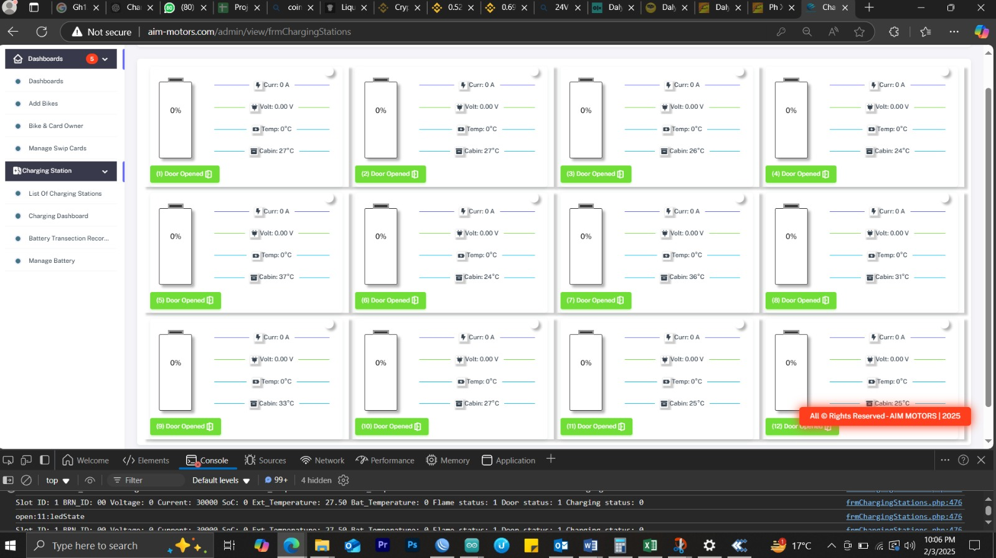
Figure1: Dashboard showing all 12 cabinets doors are opened as well as displaying cabinet temperatures too.

5. Recommendations & Next Steps
- Conduct Full-Load Testing – It is essential to perform a real-world full-load test with all 12 batteries to validate the estimated power consumption and verify system stability.
- Monitor Breaker Capacity – Ensure that the 63A main breaker is sufficient for handling the estimated 70.2A peak current draw or consider an upgrade if necessary.
- Thermal & Voltage Stability Check – While operating at full capacity, monitor the charging station temperature, wiring insulation, and voltage stability to prevent overheating or system failures.
- Optimize Efficiency – Analyze if any power factor correction or load balancing techniques can enhance the station's efficiency and performance.

6. Technical Support Availability
The electronics team is available to assist with any feedback, troubleshooting, and optimization of both hardware and firmware concerns. They will also work closely with the relevant teams to ensure smooth system operation under full-load conditions.

7. Conclusion
The charging station performs well under current conditions, and fatigue testing on February 3, 2025, confirmed that all 12 slots are functional and charging properly. However, full-load testing is still required to validate maximum power consumption and ensure safe operation. The estimated peak load is 15.4kW at 70.2A AC, and proper system checks should be conducted to avoid overload risks. The electronics team is actively monitoring the system and will provide further support as needed.

